Introduction
Foundation Models: (BERT, DALL-E, GPT-3) are trained on broad data (usually self-supervised) and can be adapted to specific tasks.
AI Engineering: Process of building applications with readily available models. Fastest growing engineering discipline.
Important for chatbots: Privacy, user feedback, performance, accuracy, traceability (show used sources).
Multimodal: Interpret multiple types of data together (e.g. text + image + sound + structured data).
Supervised: Ground truth is learned (labels), not autonomous. 4 important elements: 1) training data (input and output data including labels), 2) model, 3) loss function, 4) optimization algorithm. Drawback: Need of high-quality data labels. E.g. Img Classification. Unsupervised: Patterns in the input data are learned, Data is categorized, e.g. Clustering, PCA. Needs no labels at all (unlike (self-)supervised learning).
Self-supervised: Labels are generated from the data itself (e.g. by predicting missing words in a sentence). Self-supervision overcomes data-labeling bottleneck. But: important for GenAI models to be fair, ethical & to mitigate bias:
Bias & Fairness: Training dataset can contain biases/unethical things (sex) which may be amplified more by GenAI.
Latent Space: a hidden, compressed representation of data that models use to represent relationships in high-dimensional input. E.g. only (a,b) needed to describe ellipse in space.
Transfer Learning: involves splitting the model into a body and a head, where the head is a task-specific final network layer. Requires freezing of the body layers if a pretrained body is used. Same body for all tasks.
Fine-tuning: Retrain the whole network. When having Encoder with Classification head, you train both.
Greedy Sampling: choose next output based on the token with the highest probability (argmax sampling).
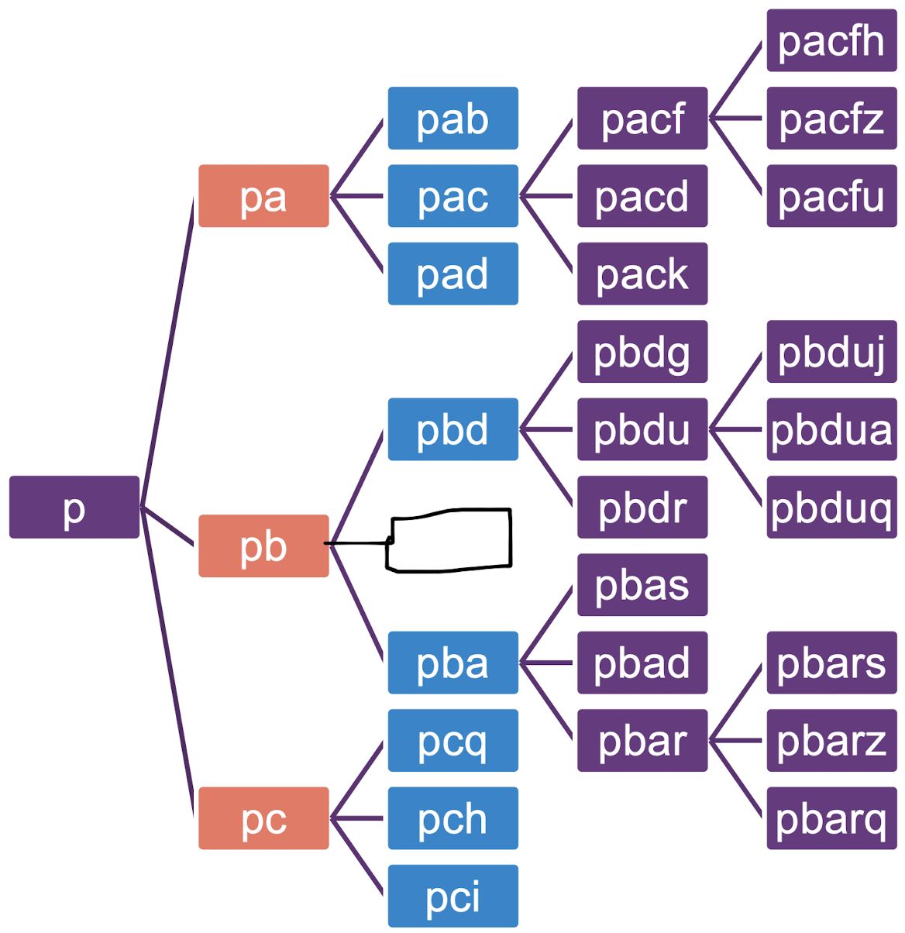
Top-k Sampling: avoid low-probability choices by sampling from the $k$ tokens with the highest probability.
Nucleus Sampling: Take all probabilities until condition is met, e.g. all until summed up probability reaches 95%.
Multinomial Sampling: Select an option randomly, but the randomness is weighted by the probabilities. Outcomes with higher probabilities are more likely to be chosen, but less probable options can still be selected occasionally.
Beam Search: chose the beam_width ($3$) highest options for beam_length ($4$) times. At each step, there are beam_width ($3$) options, and at the end the one with the highest probability is chosen. Finds the most optimal outcome.

SFT Supervised Fine Tuning & RLHF Reinforcement Learning w/ Human Feedback
SFT: Humans (expensive) create e.g. 175 tasks (perfect answers to predefined questions). Use LLM to create 52K more tasks, then use all tasks to finetune newest model = Synthetic Data Generation. But SFT is cloning behavior of ppl writing the tasks and is thus subjective/biased & can train model to hallucinate if given human answer was unknown by model itself. Better: RLHF: Humans rate multiple outputs for same instruction (not command what would be the right output) -> fine-tune model with this scoring. InstructGPT: 1) Use SFT to finetune normal model. 2) Use RLHF to train a special reward model with scoring ability. 3) Reward model finetunes normal model by scoring its prompts.

DL Deep Learning
Bigram Model: Saves the number of occurrences (PDF) of how much a bigram (two consecutive characters) occurred in the training data. For inference it samples the next character given the probabilities in the PDF. $P(c_{i}|c_{i-n+1},,c_{i-1})$
Shortcomings of bigram character-level models: Inefficiency (process each char individually), non-scalable (huge probability matrix which is sparse), no semantic understanding, no long-range dependencies.
Embeddings: more efficient than one-hot-vectors, allow model to learn relationship between characters.
Softmax: $p_{i,k}=\frac{e^{c_{i,k}}}{\sum_{j=1}^{m}{e^{c_{i,j}}}}$ $i$: sample index, $m$: num of classes, $c_{i,k}$: raw logit of class $k$ (unnormalized output)
Cross Entropy Loss for minibatch (minimize this): $l=-\frac{1}{N}\sum_{i=1}^{N}{\log\left(p_{i,y_{i}}\right)}$ (Negative Loglikelihood), $N$: num of samples in minibatch, $y_{i}$: true class label of sample $i$, $p_{i,y_{i}}$: softmax output probability for true label at sample $i$.
Weight update: $w_{t+1}←w_{t}-α\frac{∂}{∂w}\left(-\log\left(p_{i,y_{i}}\right)\right)$ $α$: learning rate
FFNN parameter count: input=16, output=5, bias=True $5∙\left(16+1\right)=85$

CNN Convolutional Neural Network
FFNN bad for images: ignores spatial structure, many params needed, overfitting, not translation invariant.
Convolution effect: extract features, (reduce dimension), enhance local pattern, preserve spatial relation.
CNNs are good for pattern detection but not for e.g. sentiment analysis because order of words is ignored.
Padding: Pad the input data to get a larger output. Stride: Size of “jumps” between convolutions.
Max pooling: takes largest value in defined kernel size, jumps according to stride, can be used to decrease output size.
Padding Variations (without considering stride): same $output size=input size$
Valid $output size=input size-kernel+1$ full $output size=input size+kernel-1$
$$Output size with stride=floor\left(\frac{output size}{stride}\right)+1$$

Metrics
$$Accuracy=\frac{TP+TN}{n}, Precision=\frac{TP}{TP+FP}, Recall=\frac{TP}{TP+FN}$$
$F_{1}$ score: harmonic mean of precision ($P$) and recall ($R$), metric to measure if both are high: $F_{1}=\frac{2PR}{P+R}$
The goal is to have a high F₁ score because it indicates a good balance between precision and recall.
Perplexity: A measure of uncertainty for LLMs. Perfect model has a score $1$, the worst score (e.g. if equal probability for all tokens) = $1/size of vocabulary$. Depends on tokenizer and benchmark. $t$ is sequence length
$$PPL\left(x\right)=\exp\left\{-\frac{1}{t}\sum_{i}^{t}{\log\left(p_{θ}(x_{i}|x_{<i}\right)}\right\}={\left(\prod_{i}^{t}{p_{θ}\left(x_{i} | x_{<i}\right)}\right)}^{-\frac{1}{t}}$$
For a sequence, $x_{1}$=”Ich”, $x_{2}$=”liebe”, $x_{3}$=”GenAI”: ${\left(p\left(Ich\right)∙p(liebe|Ich)∙p(GenAI|Ich,liebe)\right)}^{-\frac{1}{3}}$
Tokenization procedure has a direct impact on a model’s perplexity. If $t>context size$: use a sliding window strategy.

Temperature $T$
Defines how deterministic ($<1$) or creative ($>1$) a model should be. $logits_{adjusted}=\frac{logits_{raw}}{T}$
Then, Softmax applied. When $T$ is high, the logits are scaled down, making the probabilities closer to each other, which increases the chances of selecting a less likely option, hence more 'creative' outputs. When $T$ is low, the logits are scaled up, making the highest probability even more dominant. Proportion between the logits themselves is not changed by $T$, but since Softmax calculates the prob based on relative magnitudes of the logits, the probability distribution is changed by $T$.

Batch OR Layer Normalization
Batch1: Word1:[1,2,3,4,5] Word2:[5,4,3,2,1], Batch2: Word1:[2,4,6,8,10] Word2:[10,8,6,4,2] Batch: Normalize each individual feature across whole batch. Bad for seq models (diff seq lengths & small batch sizes). Calc mean&var for feature dim 1: [1,5,2,10] Layer: Normalize each of the words independently across all features. Good bc independent of batch size. Calc mean&var for word1: [1,2,3,4,5] Then: $Norm\left(x\right)=γ∙\frac{x-μ}{\sqrt{σ^{2}}+ϵ}+β$, $γ$=1, $β$=0 and will be learned

RNN Recurrent Neural Networks
Advantages: Sequential processing, understand sequence/relationship between time steps (because of hidden state), remember previous steps to generate next steps, autoregressive nature, variable input length. RNNs are explicitly unrolled during forward propagation. Same weights in each cell: parameter sharing.
Shortcomings: 1) Vanishing/exploding gradients (difficulty to learn long-term dependencies). 2) Bias towards recent inputs. 3) Sequential computation (parallelization bottleneck during BOTH training & inference).
Comparison to FFNN/CNN: FFNNs are unable to capture temporal order of time series, because they treat each input independently. CNN only partially suitable: Could flatten input and use 1D filter, then apply sliding filter over time-series. Would be able to match patterns BUT ignores spatial position in text: “I hate cinema but love books” CNN doesn’t get dependance. Lose order of words, misinterpret meaning.
Autoregressive: word is generated and used as input for the next one, ensuring continuity and context.
DeepRNNs are stacked vertically and horizontally.
Bidirectional RNNs: looks in the past as well as the future (filling blanks in a sentence). Has thus double the parameters, i.e. 2 networks: 1 RNN that moves forward + 1 RNN that moves backwards.
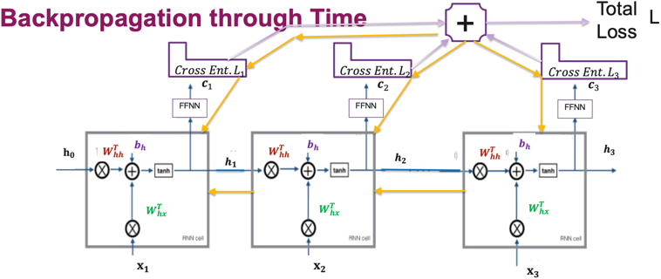
$$L=L_{1}+L_{2}+L_{3}, W_{hx}←W_{hx}-α∙\frac{∂L}{∂W_{hx}}$$
$$c_{1}=W_{hc}∙h_{1}$$  $$\frac{∂L_{1}}{∂W_{hx}}=\frac{∂L_{1}}{∂c_{1}}∙\frac{∂c_{1}}{∂h_{1}}∙\frac{∂h_{1}}{∂W_{hx}}$$ | $$c_{2}=W_{hc}∙h_{2}$$  $$\frac{∂L_{2}}{∂W_{hx}}=\frac{∂L_{2}}{∂c_{2}}∙\frac{∂c_{2}}{∂h_{2}}∙\frac{∂h_{2}}{∂W_{hx}} \\ +\frac{∂L_{2}}{∂c_{2}}∙\frac{∂c_{2}}{∂h_{2}}∙\frac{∂h_{2}}{∂h_{1}}∙\frac{∂h_{1}}{∂W_{hx}}$$ |  | $$c_{3}=W_{hc}∙h_{3}$$  $$\frac{∂L_{3}}{∂W_{hx}}=\frac{∂L_{3}}{∂c_{3}}∙\frac{∂c_{3}}{∂h_{3}}∙\frac{∂h_{3}}{∂W_{hx}} \\ +\frac{∂L_{3}}{∂c_{3}}∙\frac{∂c_{3}}{∂h_{3}}∙\frac{∂h_{3}}{∂h_{2}}∙\frac{∂h_{2}}{∂W_{hx}} \\ +\frac{∂L_{3}}{∂c_{3}}∙\frac{∂c_{3}}{∂h_{3}}∙\frac{∂h_{3}}{∂h_{2}}∙\frac{∂h_{2}}{∂h_{1}}∙\frac{∂h_{1}}{∂W_{hx}}$$
Layer In keras, only a single bias is used |  | Output Shape |  | Trainable Param count
SimpleRNN(16, input_shape=(5,10), return_sequences=True) |  | (None, 5, 16) |  | $${16}^{2}+16∙10+2∙16=448$$
SimpleRNN(units=32, use_bias=False) |  | (None, 32) |  | $${32}^{2}+32∙16=1536$$
Time Steps (5) e.g. # of tokens in sentence don’t matter for param calc (same cell), bc will be ran through sequentially.

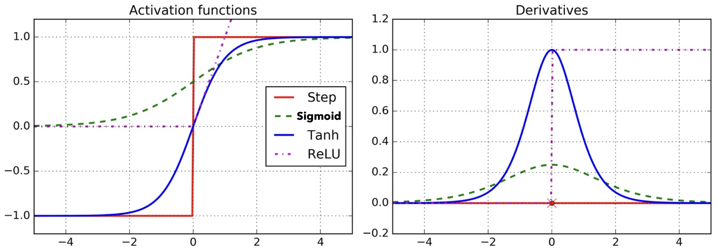
Vanishing/Exploding Gradient Problem
Both bad bc in (deep) RNNs, gradients get multiplied over and over. Vanishing: Common with sigmoid, tanh activation functions bc output saturation: sigmoid squashes input values into range $(0,1)$, thus its derivative is between$(0, 0.25)$ and tanh into range $(-1, 1)$, thus its derivative between $(0,1)$, which means tanh suffers a bit less than sigmoid from vanishing gradients. For very small/large inputs, the gradient becomes extremely small (near $0$, see figure). Results in slow or stalled learning in deep networks bc weights only get tiny updates and it’s harder to propagate errors from the loss back to the distant past. Gradient never converges to the optimum. ReLU special case. Dying ReLU Problem: Neurons output $0$ for negative inputs = gradient is exactly $0$ which is even more severe than vanishing gradient problem, effectively “killing” those neurons, portion of network becomes inactive, reducing model’s capacity to learn. Exploding: Does not happen with sigmoid, tanh, as outputs are in bounded range. Occurs with unbounded activations like ReLU when there are huge inputs or improper weight initialization. Loss jumps around and cannot get minimized. How to fix: Modern architectures often use ReLU variants (e.g., Leaky ReLU) or normalization techniques (e.g. BatchNorm) or skip connections or gradient clipping or just use LSTM/GRU to mitigate this.

LSTM Long Short-Term Memory
Information is forgotten or remembered via structures called gates. Each gate is a neural network. Downside: 4x more expensive than normal RNNs, high number of parameters. Cell State $C_{t}$ acts as LSTM’s memory.
Forget Gate: Looks at $h_{t-1}$ and $x_{t}$, and outputs a number between 0 and 1 for each number in the cell state $C_{t-1}$. A 1 represents "completely keep this" while a 0 represents "completely get rid of this". This mitigates vanishing gradients by creating paths through time that have derivatives that neither vanish nor explode.
Input Gate: The last hidden state $h_{t-1}$and current input $x_{i}$ get passed to a sigmoid and a tanh function. The tanh squishes values between -1 and 1 in order to regulate the network. Its output is multiplied with the sigmoid output. The sigmoid output will decide which information is important to keep from the tanh output.
Update Gate: The old cell state $C_{t-1}$ is multiplied by $f_{t}$ in order to forget the things we decided to forget earlier. Then $i_{t}∙{\tilde{C}}_{t}$ is added. This is the new candidate values, scaled by how each state value should be updated.
Output Gate: A sigmoid layer decides what parts of the cell state is being output. Then, the cell state is passed to a tanh (to push the values to be between −1 and 1 and multiplied it by the output of the sigmoid gate for filtering.
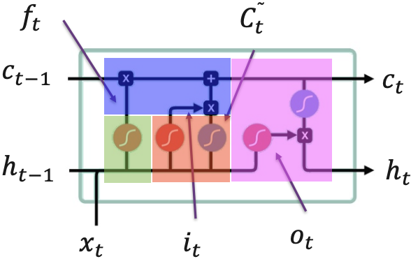
Intuition behind LSTMs and vanishing gradient: The gradient contains forget gate’s vector of activations, which allows network to control gradient values, at each time step, using suitable param updates of the forget gate. Also, the cell state $c_{t}$ gradient is added up. Additive expression less likely to vanish. ↓blue=tanh,red=sigmoid. All ops elementwise

$$f_{t}=σ\left(W_{fh}∙h_{t-1}+b_{fh}+W_{fx}∙x_{t}+b_{fx}\right)$$
$$i_{t}=σ\left(W_{ih}∙h_{t-1}+b_{ih}+W_{ix}∙x_{t}+b_{ix}\right)$$
$${\overline{C}}_{t}=\tanh\left(W_{ch}∙h_{t-1}+b_{ch}+W_{cx}∙x_{t}+b_{cx}\right)$$
$$C_{t}=f_{t}⊙C_{t-1}+i_{t}⊙{\overline{C}}_{t}$$
$$o_{t}=σ\left(W_{oh}∙h_{t-1}+b_{oh}+W_{ox}∙x_{t}+b_{ox}\right)$$
$$h_{t}=o_{t}⊙\tanh\left(C_{t}\right)$$
In keras, only a single bias is used per gate.
Layer (units = hidden state dimension size) | Output Shape | Trainable Param count
LSTM(10,input_shape=(6,2),return_sequences=True) | (None, 6, 10) | $$4\left({10}^{2}+10∙2+2∙10\right)=560$$
LSTM(units=3, use_bias=False) | (None, 3) | $$4\left(3^{2}+3∙10\right)=156$$
The number of Time Steps (6) doesn’t change the # of parameters (same cell). 2 is the embedding dimension (features).

GRU Gated Recurrent Unit
GRUs got rid of cell state (less params now) and uses the hidden state to transfer information.
Reset Gate ($r_{t}$): remembers short-term connections and indicates which info of $h_{t-1}$ should be forgotten.
Update Gate ($z_{t}$): acts similar to the forget and input gate of an LSTM. It decides what information to throw away and what new information to add. It is used to memorize the long-term connections. Computes $\tilde{h_{t}}$.
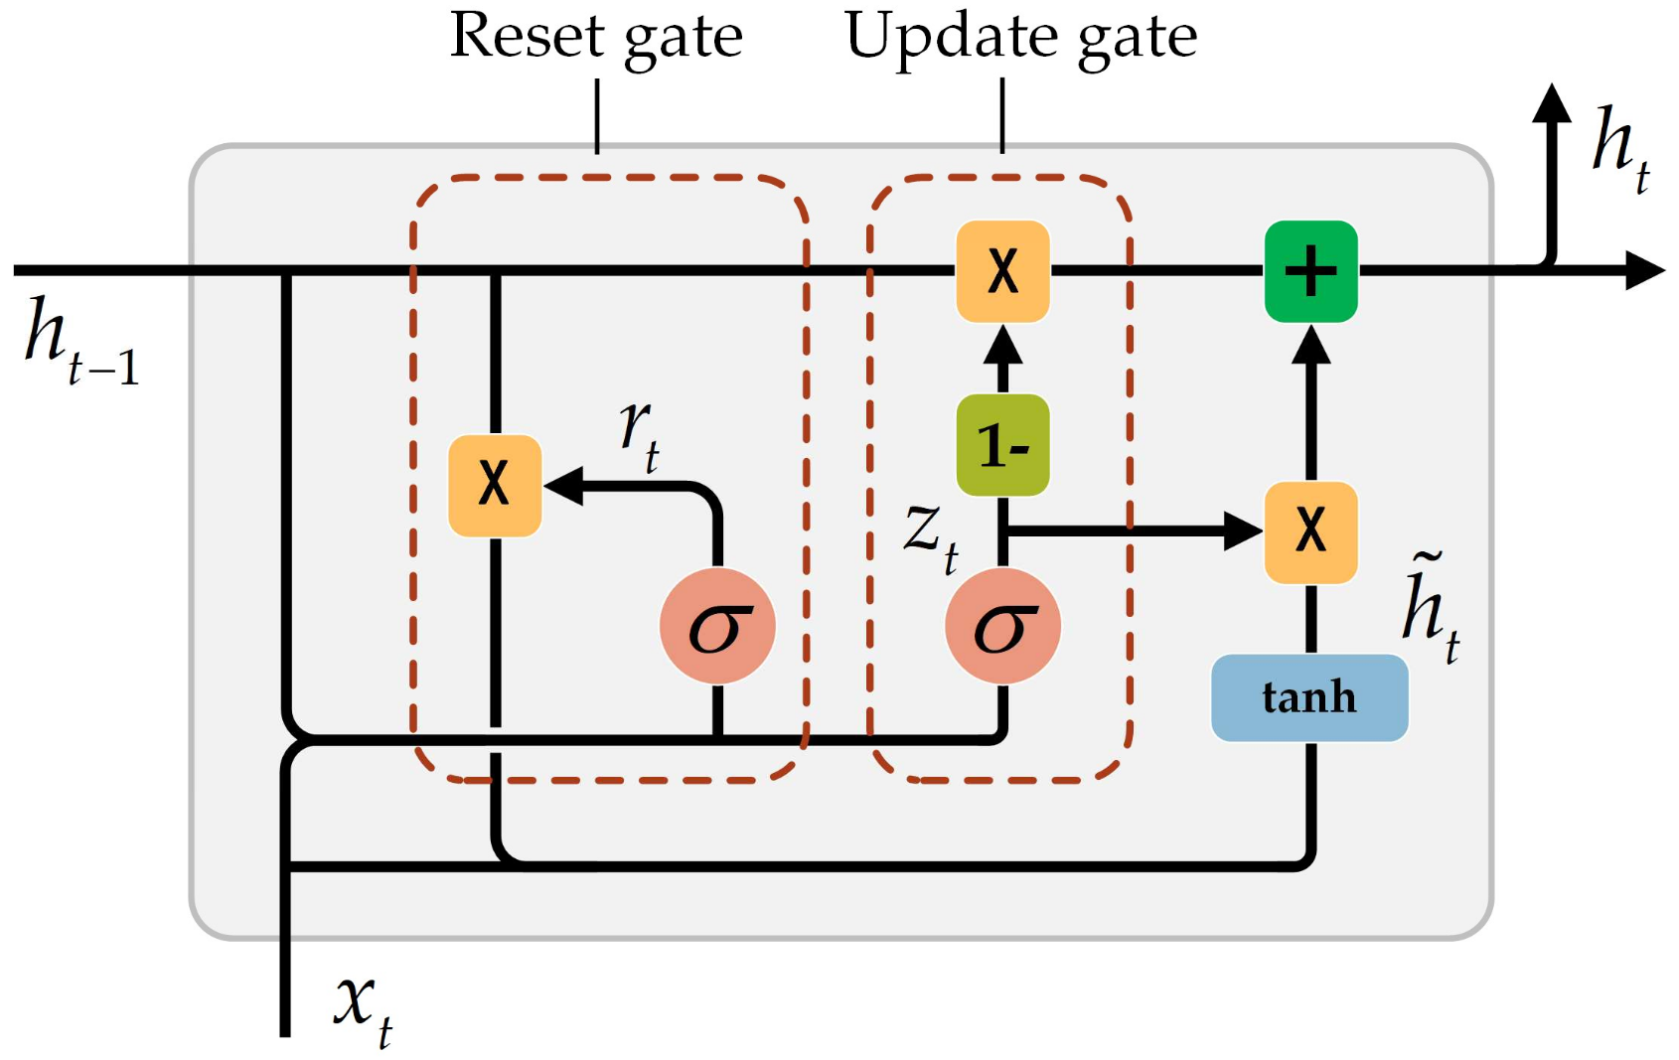
Output: The final hidden state $h_{t}$ is combination ($+$) of prev hidden state $h_{t-1}$ and candidate hidden state $\tilde{h_{t}}.$

$$z_{t}=σ\left(W_{zh}∙h_{t-1}+b_{zh}+W_{zx}∙x_{t}+b_{zx}\right)$$
compact form: $z_{t}=σ\left(W_{z}∙\left[h_{t-1},x_{t}\right]+b_{z}\right)$
$$r_{t}=σ\left(W_{rh}∙h_{t-1}+b_{rh}+W_{rx}∙x_{t}+b_{rx}\right)$$
$${\tilde{h}}_{t}=\tanh\left(W_{hh}∙\left(r_{t}⊙h_{t-1}\right)+b_{hh}+W_{hx}∙x_{t}+b_{hx}\right)$$
$$h_{t}=\left(1-z_{t}\right)⊙h_{t-1}+z_{t}⊙{\tilde{h}}_{t}$$

Layer | Output Shape | Trainable Param count
GRU(units=10,input_shape=(6,2),return_sequences=True) | (None, 6, 10) | $$3({10}^{2}+10∙2+2∙10)=420$$
GRU(units=3, use_bias=False) | (None, 3) | $$3\left(3^{2}+3∙10\right)=156$$
LSTM vs. GRU: GRU combines LSTM’s forget & input gate into a single update gate. Decision what to forget & add is no longer made independently. Only something will be forgotten if something new is added instead. In GRU, cell state = output: GRU unit controls flow of information without having to use a cell memory unit. But thus, GRU & RNN expose the complete memory (unlike LSTMs) without any control. Application & dataset decide which is useful.

seq2seq Models
A sequence-to-sequence model is a new architecture, it’s a model that takes a sequence of items (words, letters, features of images, etc.) and outputs another sequence of items. Under the hood, a seq2seq model is composed of an encoder and a decoder which are two individual RNNs (such as LSTM or GRU models). Encoder encodes ALL input tokens into embedding vectors. Job is to produce context “tensor”. Decoder‘s Job is to iteratively autoregressively generate output tokens using the embeddings. Limitations: The context vector turned out to be a bottleneck. Better to have context $c$ as input with every decoder step (but still, only the last hidden state is passed as context to decoder, like attention). It made it challenging for the models to deal with long sentences. Its sequential nature = bad (first encodes, passes context vector to decoder, decoder runs). Solved by Attention: With Transformers, you can get rid of encoder, but decoder still needs to be autoregressive.
At the end of a seq2seq model, a FFNN is used to get from the hidden state dimension to the output vocabulary size dimension. Afterwards, a softmax to get the probabilities of all possible tokens, then argmax to the get next token.
One-to-One: Traditional FFNN case (classification/regression). Many-to-One: Sentiment Classification.
One-to-Many: Image Captioning, Music generation given starting note. Many-to-Many: Machine Translation

BLEU_ngram Score (Bilingual Evaluation Understudy)
Metric for comparing a generated text to one or more reference texts. BLEUₙ score for n-grams focuses on the sentence meaning for low $n$, and focuses on well-formed sentences for high $n$.
MEAN_BLEU: Scores with $n$ between $1$ and $4$ have the best correlation with human evaluation.
Brevity Penalty (BP): Penalty for candidate translations whose length is less than the ones of the reference translations. $BLEU=BP*MEAN_BLEU$. Gets improved by Attention.

Attention (Bahdanau - additive attention)
Attention allows the model to focus on the relevant parts of the input sequence as needed. Instead of passing only the last hidden state of the encoding stage, the encoder passes all the hidden states to the decoder. Each hidden state the decoder receives (sent by encoder) is given a score which is passed to a softmax and then multiplied with the corresponding hidden state. An alignment score between the decoder’s current hidden state and each of the encoder’s hidden states is computed by using a small NN. The context vector for the decoding step, is a weighted sum of the encoder’s hidden states with the attention scores. Encoder processes each word of the English input ("I am going to school") and produces hidden states. Decoder uses attention to focus on the relevant parts of the input when generating each word of the German output ("Ich gehe zur Schule").
Alignment Scores: Computed by using a small NN. Help decide how much attention to give each input word.
Attention Weights: Are softmaxed/normalized alignment scores, highlight relevant words in input sequence.
Context Vector: ${s'}_{j}$ is the output of the attention block (cumulated hidden states of encoder weighted based on decoder’s query).
Decoder passes $s_{j}$(=Query) to attention block and asks“To what encoder hidden step(=Key) should I pay attention to?”
Attention block has all the hidden states $h_{i}$ from the encoder at once (aka context $c$). The decoder is autoregressive and queries the attention block at every time step, which returns what hidden states the decoder should pay attention to ($s’_{j}$).
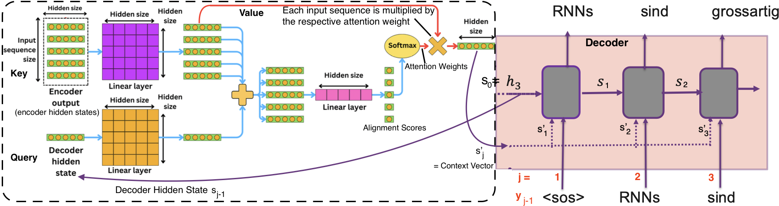
↑ Value has its own $hidden size×hidden size$ weight matrix. Problems: Scalability, computational costs, non-parallelizable (impossible with RNNs). They still struggle with super long-term dependencies/sequences/memory

Transformers
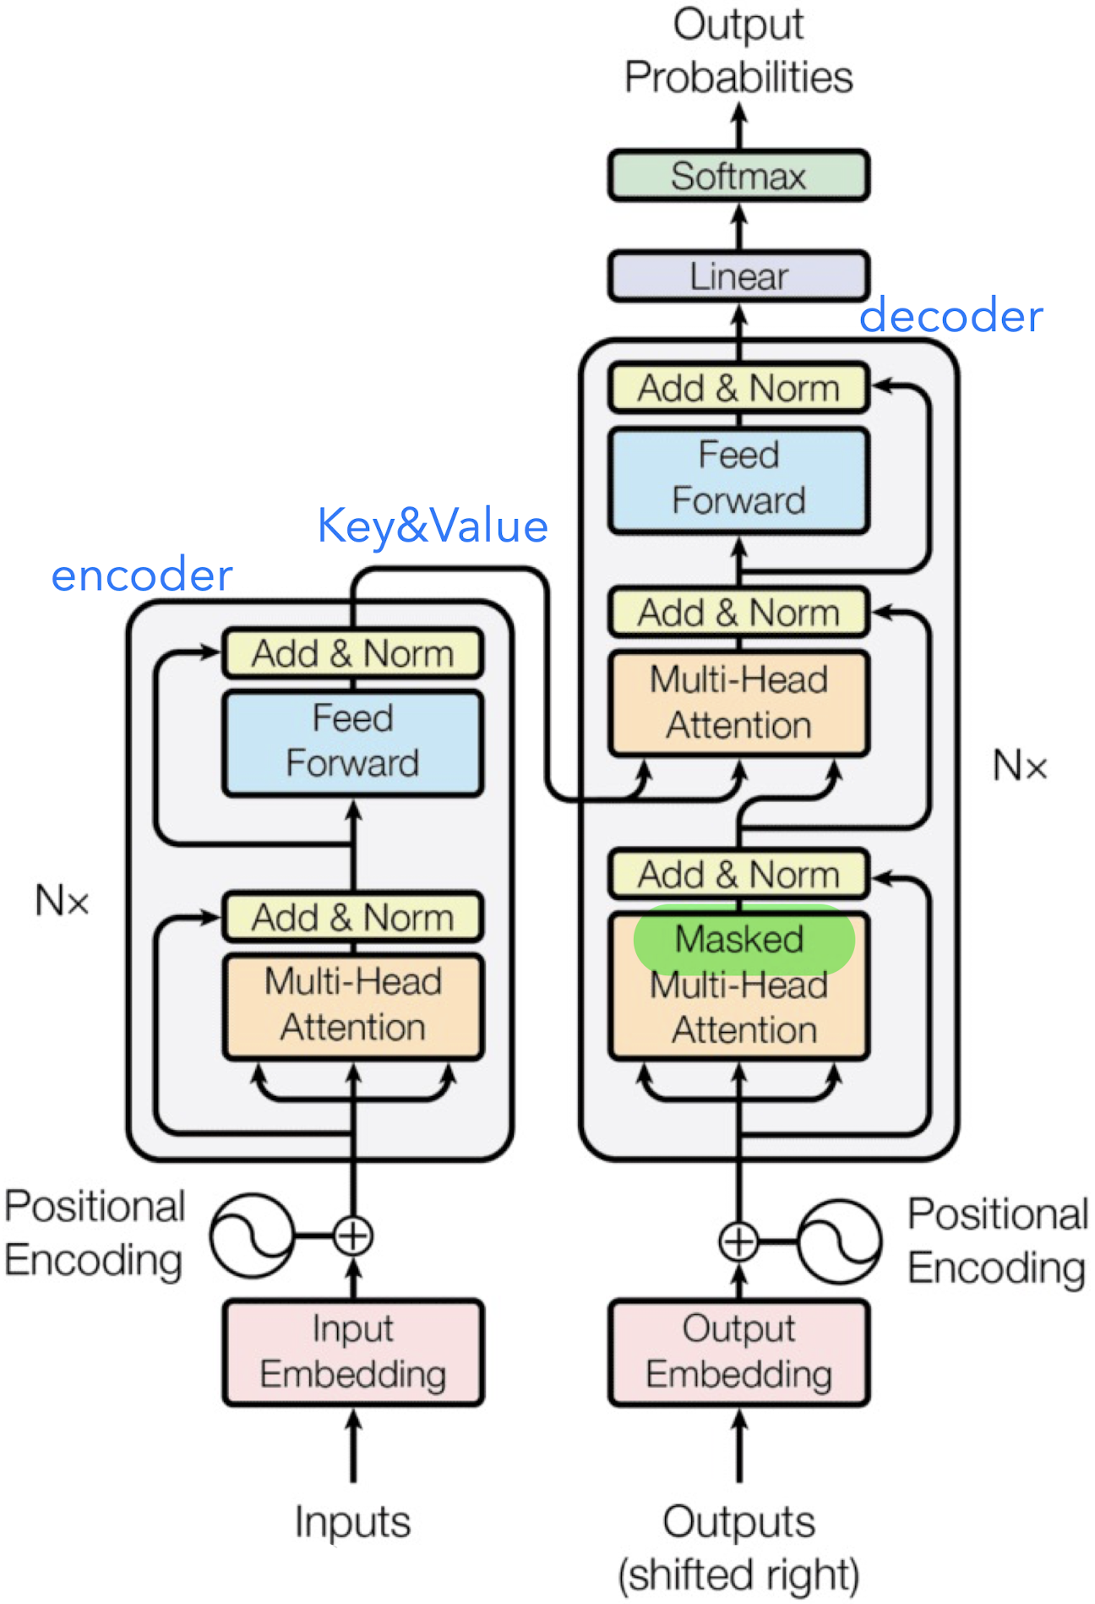
Get rid of recurrency of RNNs but must be autoregressive (last decoder output is again fed as input). In order to preserve the sequential nature of the data when using parallelization in the encoder, a position-aware encoding is needed. This is then just added to the normal embedding (not concatenated but merged, same embedding dimension size). $angle_rates=1/{10000}^{\frac{2[i/2] }{d}}$, where $2\left[i/2\right]$ effectively rounds down embedding dimension $i$ to nearest even number. In absolute positional encoding, sin(angle_rates) is used for even dimensions, and cos for uneven, which can lead to a vertical stripes pattern when visualizing the position encodings.
The attention scores can be seen as the “cosine similarity” (actually: scaled dot product) of Query and Key.
The context size defines the number of tokens a network can process.
The output is a probability distribution over all possible tokens which are then sampled from. To generate a sequence, the output is fed again as an input in an autoregressive manner.
Multihead Attention: uses multiple attention blocks (amount can be configured via a hyperparameter) to capture relationships to different parts of the sequence. head_dim = embedding_dim // num_heads (thus, head_dim is often small) to ensure embedding_dim is reached again when all heads’ outputs are concatenated again & for computational efficiency.
Self-Attention: Q, K, V all work on the same dataset (input sequence). The tokens (e.g. in a sentence) are paying attention to themselves.
Cross Attention: “2 attentions”: Sentence paying attention to itself, and the sentence is also paying attention to the encoder’s contextualized embedding. Query comes from decoder’s previous masked multi-head attention block’s outputs (self-attention), and Key and Value are the contextualized embeddings, i.e., output of the encoder. In a translation scenario, the Query is the sentence in the target language and Key and Value are the encoder hidden states extracted from the sentence in the original language.
Masked Attention/Causal Masking: Future tokens are masked out during training of the decoder, so future is not visible to the decoder (lower triangular matrix is set to $-∞$, after softmax = $0$). Otherwise, decoder would cheat when predicting tokens. Prevents decoder from using info that has not yet been predicted. Encoder does NOT need masking since encoder needs to have the whole context of the input sentence.
Layer Normalization & Skip Connections: Ensure numerical stability & preserve some info to be passed through network (avoids vanish-grad). Post-Layer Norm: Layer Norm placed in between skip connections. Tricky to train as gradients can diverge, requires learning rate warm-up. Pre-Layer Norm (better): Layer Norm placed within span of skip connections. Much more stable during training, doesn’t require learning rate warm up.
Teacher Forcing: Use the ground truth as the next input during training rather than the potentially incorrect prediction of the model. But during inference, model may have more difficulties recovering from series of wrong pred. Mitigate by using Curriculum Learning: Gradually increases complexity of training examples from easy to difficult. Knowledge Distillation: Technique to compress large model (teacher) into smaller model (student) by training it to reproduce behavior of the teacher. E.g. DistillBERT 60% size of BERT while still 97% quality & 60% faster. Rather than training with cross-entropy on hard targets, knowledge is transferred with cross-entropy over soft targets (probabilities of teacher)
Advantage over RNN/LSTM/GRU: better quality, speed i.e. training parallelization (encoder forward pass only because decoder is still autoregressive), less training cost. Note: during training, backpropagation goes from decoder to encoder (backpropagated as a whole).

Single Attention Head
Query: to compute the relationship between the current token and all other tokens. In training the Q is the translated target sentence (the results of the decoder) while K and V come from the encoder’s processed sentence in the original language. The query vector (e.g. decoder hidden state) is passed to a FFNN resulting in a vector in Query space which should encode accumulated information. Represents current token that is seeking information: “What am I looking for?” E.g. “Any adjectives in front of me?” Result is the similarity to the closest Key from a token database.
Keys: Same as in Query: the embeddings of the tokens are passed to a FFNN to be in a lower dimensional space. Usually has all the hidden states from the encoder. Represents information content of all tokens in the sequence: “What do I have to offer?” E.g. “I am an adjective!”. Value: Is multiplied by the attention of Q and K which should encode a change that should be added to the original embedding. Contains actual data/info content of each token: “I am word ‘fluffy’, and this is how much your vector needs to be moved to reflect this.”
$$Attention\left(Q,K,V\right)=softmax\left(\frac{Q∙K^{T}}{\sqrt{d_{k}}}\right)∙V$$
$softmax\left(\frac{Q∙K^{T}}{\sqrt{d_{k}}}\right)$ holds the probabilities of how the Query and Key pay attention to each other. $d_{k}$: #dimensions of Key The $Attention\left(Q,K,V\right)$ is then added to the original embedding for each token to achieve a more contextually rich meaning.
Context Vector $s’_{j}$: Attention weights multiplied by the Value Matrix, result of $Attention(Q,K,V)=s’_{j}$

Tokenization: split text into tokens, Numericalization: Convert token to int
Words of an input sentence are split up into tokens which are then encoded as vectors (embeddings). Every model has a large vocabulary (~50k tokens) which is stored in an embedding matrix showing the vector representations (embeddings) (12’288 dimensions in GPT-3) for each token. The embeddings are learned in a training step. The vectors in the high dimensional space tend to have a semantic meaning (similar words have similar vectors) after training.
Char Tokenization: Ignores structure in text, expensive as linguistic structures need to be relearned. Work Tokenization: Preserve some structure, split into words and map words to int. Subword Tokenization: Hybrid, best token-splits are learnt. First, every char is a token, then merge common pairs, repeat. Tokenization -> “Token” “ization”

Agents
LLMs are stateless. Context (in other words, message history) needs to be saved externally. LLMs do support large context (hundreds of tokens) but quality of response is affected, and one has to pay per token. By using an LLM, the message history can be summarized. Better: RAG can send only relevant user info in respect to user’s query.
Agents: systems that leverage an LLM to determine which actions they should take and in what order. Agents need tools such as for multiplication, encryption, etc.
ReAct (Reasoning, Acting): 3 steps: Thought (describes the current situation), Action (two types: search/calculate), Observation (result of an action). Allows to generate reasoning traces which allow the model to induce, track, and update action plans, and even handle exceptions. ReAct-format trajectories are needed which consist of multiple thought-action-observation steps. The thoughts are used to achieve tasks such as decomposing questions, extracting information, performing commonsense/arithmetic reasoning, guide search formulation, and synthesizing final answer.

RAG Retrieval Augmented Generation
Can be used to filter a list of possibilities for the top-k matches. E.g. only pick relevant internal documents for context.
Use small model/embedding model to generate vector representations of the chunks, then store in vector DB.
R: When user queries system, the query is also converted into embedding, retrieves most relevant chunks (e.g. internal documents) based on the embeddings’ (i.e. vectors’) cosine similarity.
AG: The found chunks are then passed to an LLM as context to generate a response or perform a task.
Shortcomings: “Closeness” threshold for cutoff (only top-k). Can’t find exact matches (fix by using hybrid search, i.e. complementing RAG with semantic search and/or keyword search). Challenging in domains other than the ones trained (trained on Wikipedia, test on legal documents = bad) RAG Examples: FAISS, haystack, pinecone, pgvector
Langsmith/Langfuse: costs tracking, statistics, prompt management, traces. DSPy: Program LLM with Python.
RAGAS (Retrieval-Augmented Generation Answer Similarity): Measures relevance, faithfulness, Groundedness.

Chunking Strategies bc we cannot feed very long texts to LLMs
Preprocessing: Important info can be hidden in Filenames, Folder Structures & URLs. Capture by copying into chunk.
One vector per document: Truncating (cutoff) the doc OR create chunks, embed them and aggregate (average) them
Downside: Highly compressed OR truncating -> loss of information. Better would be:
Many vectors per document: Split doc into many chunks: each line may be a chunk, or each paragraph may be a chunk, and you may want to have the chunks overlap to avoid losing context at the boundaries of chunks.

Large Contexts
Performance can degrade significantly when changing the position of relevant information. Current language models do not robustly make use of information in long input contexts. Solution: Reranking:
- Maximize retrieval recall by retrieving plenty of documents. Recall = 1 when u just classify all documents as relevant
- Maximize LLM recall by minimizing the number of documents that are sent to the LLM.
- Reorder (rerank) retrieved documents and send only the most relevant documents to the LLM
$$recall=\frac{TP}{TP+FN}=\frac{\#of relevant docs returned}{\#of relevant docs in dataset}$$
Reranking: 1. Feed the query and a single doc to a transformer. 2. Run inference 3. Get a similarity score & reorder

AE Autoencoder
A NN that is trained to perform encoding and decoding an item such that the output is as close to the original item as possible by using a context vector that is as small as possible. The latent space is used for lower dimensionality of the encoding. Sampling from the latent space will allow to generate new images when passed through the decoder.
Anomaly Detection: AEs particularly suited for this as they are trained on normal images without anomalies. When presented with anomaly image, the AE struggles to reconstruct it accurately bc it has not seen this during training, results in large reconstruction error which can be used to identify anomalies.
AE Problems: 1) Distribution not symmetrical around center. 2) Gaps in the distribution in the latent space.
3) Latent space is not guaranteed to be continuous (point close to another may not be decoded satisfactorily) -> VAE
Loss functions: (Root) Mean Squared Error: $L_{RMSE}=\sqrt{\frac{1}{N}∙\sum_{i=1}^{N}{{\left(y_{i}-{\hat{y}}_{i}\right)}^{2}}}$ use for continuous outputs (regression)
Binary Cross Entropy (asymmetric): $L_{BCE}=-\frac{1}{n}\sum_{i=1}^{N}{\left[y_{i}∙\log\left({\hat{y}}_{i}\right)+\left(1-y_{i}\right)∙\log\left(1-{\hat{y}}_{i}\right)\right]}$
Cross Entropy: $L_{CE}=-\frac{1}{n}\sum_{i=1}^{N}{\left[y_{i}∙\log\left({\hat{y}}_{i}\right)\right]}$, Categorical Cross Entropy: $L_{CCE}=-\frac{1}{n}\sum_{i=1}^{N}{\sum_{j=1}^{m}{\left[y_{ij}∙\log\left({\hat{y}}_{ij}\right)\right]}}$

Convolution & Convolution Transpose
CNN AEs perform better than FFNN AEs because they can capture spatial relationships in images and use parameter sharing. CNN Training time may be longer for same number of Epochs.
Effect on performance if we tweak: Higher latent_space_dim: Better reconstruction quality but risk of overfitting. Lower latent_space_dim: Better generalization but poorer reconstruction quality if too small.
Convolution: $output size=ceil\left(\frac{floor\left(img size+2∙padding - kernel size\right)}{stride}\right)+1$ for padding size: see CNN topic
A Convolution Transpose layer with stride=2 doubles the size of the image.

VAE Variational Autoencoder
Aims to regularize the latent space by creating standard normal distributed dimensions. Instead of a single value for each latent space dimension, we have a probability distribution. Captures key features well, loses fine details.
For input (e.g. img), AE learns 1 point, VAE learns 2 things: mean $μ=\frac{1}{N}\sum_{i}^{N}{x_{i}}$ and variance $σ^{2}=\frac{1}{N}\sum_{i}^{N}{{\left(x_{i}-μ\right)}^{2}}$
To convert the values of a normal distribution to a standard normal distribution (z-score): $z=$ $\frac{x – μ}{σ}$
To make an encoder output a multivariate (=mehrdimensionale) standard normal distribution, the output layer of the encoder should have one neuron for the mean and one for the variance (actually log variance) of each dimension.
To improve training/numerical stability the standard deviation is enforced to be non-negative and thus in range $\left[-∞;+∞\right]$ when using the log variance: $σ=e^{\log\left(σ\right)}=e^{\frac{2∙\log\left(σ\right)}{2}}=e^{\frac{\log\left(σ^{2}\right)}{2}}=e^{\frac{log_var}{2}}$
Sampling directly from a normal distribution is not differentiable which is why the reparameterization trick is needed to separate randomness (now in $ϵ$) from the parameters ($μ$, $σ$) making $z$ differentiable and sample point $z$in latent space ($ϵ\sim N(μ=0,σ^{2}=1)$):$z=μ+σ∙ϵ$. Gradients can now flow through $μ$ and $σ$.
BatchNorm used after every convolutional layer to stabilize training.

In addition to reconstruction loss, we also use the Kullback-Leibler divergence which is minimized when $μ=0, log_var=1$ for all dimensions. Penalize network for encoding $μ$ or $log_var$far from std norm distribution.
$$L_{KL}=-0.5∙\sum^{dimensions}{(1+log_var-μ^{2}-e^{log_var})}$$
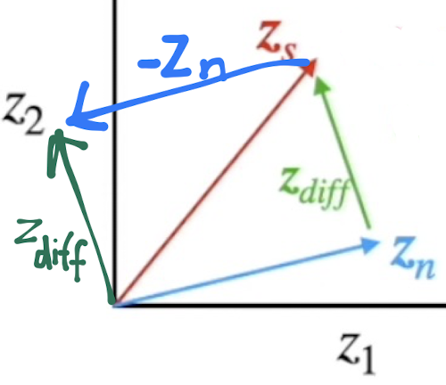
Make face more smiley: Average all “smile” labeled imgs into one vector and all “no smile” labeled imgs into another vector. Then find smile increasing vector (vector that points in direction of increasing smile): $z_{smile}=z_{s imgs}-z_{ns imgs }$, then $z_{more smiley img}=z_{original img}+α∙z_{smile}$
Gradually move from start vector to end vector in the latent space: $z_{transit}=z_{start}∙\left(1-y\right)+z_{end}∙y$
Advantages: latent space is organized (symmetrically) and allows interpolation between points in the latent space. Disadvantages: VAEs often are only able to produce these blurry images because of the loss caused by the latent space compression, i.e. the reconstruction loss. GAN has a discriminator which judges the quality of the generated image, and the GAN learns/improves because of that, thus GAN is sharper.

GAN Generative Adversarial Networks
Purpose: Create data indistinguishable from real, as if from same underlying distribution. Audio, Text, Img. E.g.: Create Art. Image restoration. Inpainting. Super-resolution. Healthcare & autonomous driving uses GANs to augment datasets.
Generator: Start from random noise to generate images that look as if they are from the original dataset. Input: a vector drawn from a multivariate std. normal distribution – convert the vector in the latent space to an image.
Discriminator: Will classify if the image is from original dataset or from the generator. 1 if real, 0 if generated (uses sigmoid in output layer). Use the output of the discriminator to make the generator better (use it in the loss function)
DCGAN (Deep Convolutional GAN =CNN GAN): GeneratorConvolution Transpose Layers, DiscriminatorConvolution.
FFNN GAN vs. DCGANs: FFNN GAN struggles to capture spatial information, outputs flattened vector reshaped to img, has more training instability, usually no BatchNorm. DCGAN preserves spatial information, more realistic outputs.
Loss: Binary cross entropy (see Autoencoder chapter)
The generator training process is supposed to generate real looking images. The generated batch of images is passed to the discriminator to get a score for each image. The loss function for the generator is then simply the binary cross-entropy between these probabilities and a vector of 1’s (real). In other words, for the loss function, you need to flip the labels of the generated images (0→1) on purpose to train the generator towards creating real (1) looking images.
When training generator, you do not touch the model params of the discriminator and vice versa.
Thus, we cannot train generator and discriminator simultaneously (discriminator would always predict that generated images are real because label=1 for generator training, it is easy to cheat bc it would just make the discriminator adjust itself to be weak). Thus, we need to do it in alternating manner, and the weights of either need to be frozen.
Discriminator might get too strong. Bad bc generator cannot get any cues for learning. Gradient for Generator starts to vanish and Generator can’t improve. How to weaken Discriminator? During discriminator training: slow down learning rate, increase dropout, reduce nr of convolutions, add noise to the labels, flip labels randomly.
Mode Collapse: If discriminator is not powerful enough, generator finds ways to easily trick the discriminator with a small sample of nearly identical images. Fix by implementing the opposite of what was said just before ↑.

GAN-generated images are often sharper than VAE-generated images because there’s a discriminator. VAE samples from a continuous distribution in low-dim latent space which sacrifices details, makes everything blurry, etc.

GAN Difficulties: 1) difficult to monitor. 2) lack of correlation between the generator loss and image quality, because: 3) the generator is only graded against the current discriminator (the discriminator is constantly improving)

Diffusion Models
Even higher quality than GANs. A Deep Neural Network is trained to remove noise from an image. New images will be generated by giving the model noise and the model then denoises it and outputs an image.
Differences to VAE/GAN: VAE/GAN generate final output in a single forward pass. Diffusion Model generate the output by iterating over many steps (iterative refinement). Allows model to correct prev mistakes -> high quality generations. AE/VAE are not good choices for this task because they are less capable of making pixel level predictions since they must reconstruct from low-dim latent space. However, diffusion models perform their operations in the latent space.
Training: consists of corrupting an image, $q\left(x_{t} | x_{t-1}\right)$, then tuning the weights to predict the noise, $p_{θ}\left(x_{t-1} | x_{t}\right)$ , and removing the predicted noise from the noisy initial image. Inference: Start with pure noise
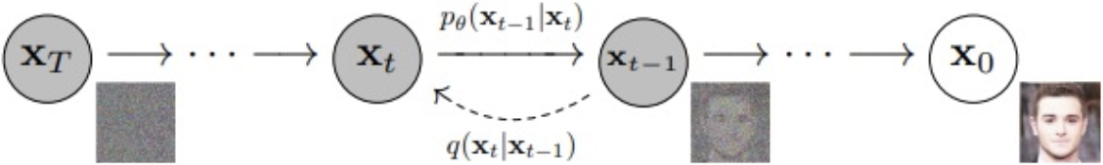
Original images $x_{0}$ are transformed to have 0 mean and 1 variance (std normal distribution). Distribution of each pixel over all images. Every timestep $x_{t}$ also has $μ$=0, $σ^{2}$=1. Noisy image $x_{T}$ must be indistinguishable from gaussian noise, which means that $T$ must be large enough (i.e. enough steps) and that $x_{T}$ must also have $μ$=0, $σ^{2}$=1.
Forward Diffusion: Function $q$ gradually adds small noise $ϵ$ with variance $β_{t}$ to $x_{t-1}$ with $ϵ\sim N\left(μ=0,σ^{2}=1\right)$.
$x_{t}=q\left(x_{t} | x_{t-1}\right)=\sqrt{1-β_{t}}∙x_{t-1}+\sqrt{β_{t}}∙ϵ_{t-1}$ $x_{t-1}$ has mean=0 and variance=1
Var of $x_{t}$ is again $1$, because: $Var\left(x_{t}\right)=Var\left(\sqrt{1-β_{t}}∙x_{t-1}+\sqrt{β_{t}}∙ϵ_{t-1}\right)=Var\left(\sqrt{1-β_{t}}∙x_{t-1}\right)+Var\left(\sqrt{β_{t}}∙ϵ_{t-1}\right)$
$=\left(1-β_{t}\right)∙\underset{1 by definition}{\underbrace{Var\left(x_{t-1}\right)}}+β_{t}∙\underset{1 by definition}{\underbrace{Var\left(ϵ_{t-1}\right)}}=\left(1-β_{t}\right)+β_{t}=1$ because: $Var\left(c∙X\right)=c^{2}∙Var\left(X\right)$
Reparameterization Trick: Also possible to jump straight from an image $x_{0}$ to any noised version $x_{t}$ directly:
$$\begin{matrix}x_{t}=\sqrt{\overline{a_{t}}}∙x_{0 }+\sqrt{1-\overline{a_{t}}}∙ϵ & \left(linear?\right) \overline{a_{t}}=a_{1}∙a_{2}∙a_{3}∙…∙a_{t}=\prod_{i=1}^{t}{a_{i}} \end{matrix} a_{i}=1-β_{i}$$
$β_{t}$ and $\overline{a_{t}}$ are NOT constant at each time step $t$. Known variance/diffusion schedule $β_{0}<β_{1}<…β_{T}<1$
Linear $β_{t}$ Schedule: early stages smaller noising steps, later stages bigger noise steps… dumb, img is already very noisy
Cosine $β_{t}$ Schedule (better): more gradual noise addition $\begin{matrix}\overline{a_{t}}=\cos^{2}\left(\frac{t}{T}∙\frac{π}{2}\right) & x_{t}=\cos\left(\frac{t}{T}∙\frac{π}{2}\right)∙x_{0}+\sin\left(\frac{t}{T}∙\frac{π}{2}\right)∙ϵ\end{matrix}$
Reverse Diffusion: A NN with parameters $θ$ is used to learn how to undo the noising process: $p_{θ}\left(x_{t-1} | x_{t}\right)$.
An image $x_{0}$ is transformed by $t$ noising steps. The new image, $x_{t}$, along with the noising rate ${\overline{a}}_{t}$ are passed to the neural network which aims to predict the noise $ϵ$ that was added to $x_{0}$ for timestep $t$. $L_{MSE}={\left(ϵ_{true}-ϵ_{θ}\left(x_{t}\right)\right)}^{2}$
Conditioning: A Transformer Language Model is used to steer the noise predictor. The prompt is converted to an embedding that is understandable by the noise predictor (e.g. sinusoidal embedding).

U-Net
U-Nets are made up of a series of downsampling (reducing img size) and upsampling (increasing img size) blocks. It has skip connections that allow information to shortcut parts of the network and flow through later layers (mitigates vanishing gradient issues). Deeper U-Net = tinier gradient. Inputs: Noise variance & Noisy image.
Model predicts the total amount of noise that was added to $x_{0}$, not the noise added in one step of the noising process.
Additional stuff that didn’t fit onto the 2 A4 pages:

Encoder-Only Transformer
Encoder only creates representation, i.e. hidden states, i.e. contextualized embeddings. However, you just put a classification head on the Encoder Body, the hidden states are fed as features to the classification head.

Decoder-Only Transformer
Decoder auto-completes sentence using autoregression. Training: compare prediction with true label. There is no cross-attention because the encoder part is missing. Depends only on input and convo history.

Steps for Autoregressive Lang models: 1. Tokenize/Create Embeddings 2. Forward Pass 3. Calculate Crossentropy Loss 4. Backward Pass 5. Sample from Probabilities (using ArgMax, BeamSearch, Top-k, Temperature) 6. Detokenize. Step 5 & 6 are only during Inference.

Prompt
Consists of persona (You’re…) + instruction (summarize) + context + data_format + audience + tone + data
One-shot:
Chain-of-thought:
Zero-shot-chain-of-thought:

Reflection Agents
Reflection: Is when there are 2 agents, one is retrieving the user’s prompt, generates an answer. That answer is then judged by another agent, the “reflection” agent. Reflection is forwarded to first LLM which then generates a new answer based on the reflection. Repeated N times before answer is returned to user. But Reflection LLM is not grounded. Better: Reflexion: Reflection Part grounds its criticism in external data. Forced to generate citations and show missing aspects when criticizing generated answer.

Diffusion Models

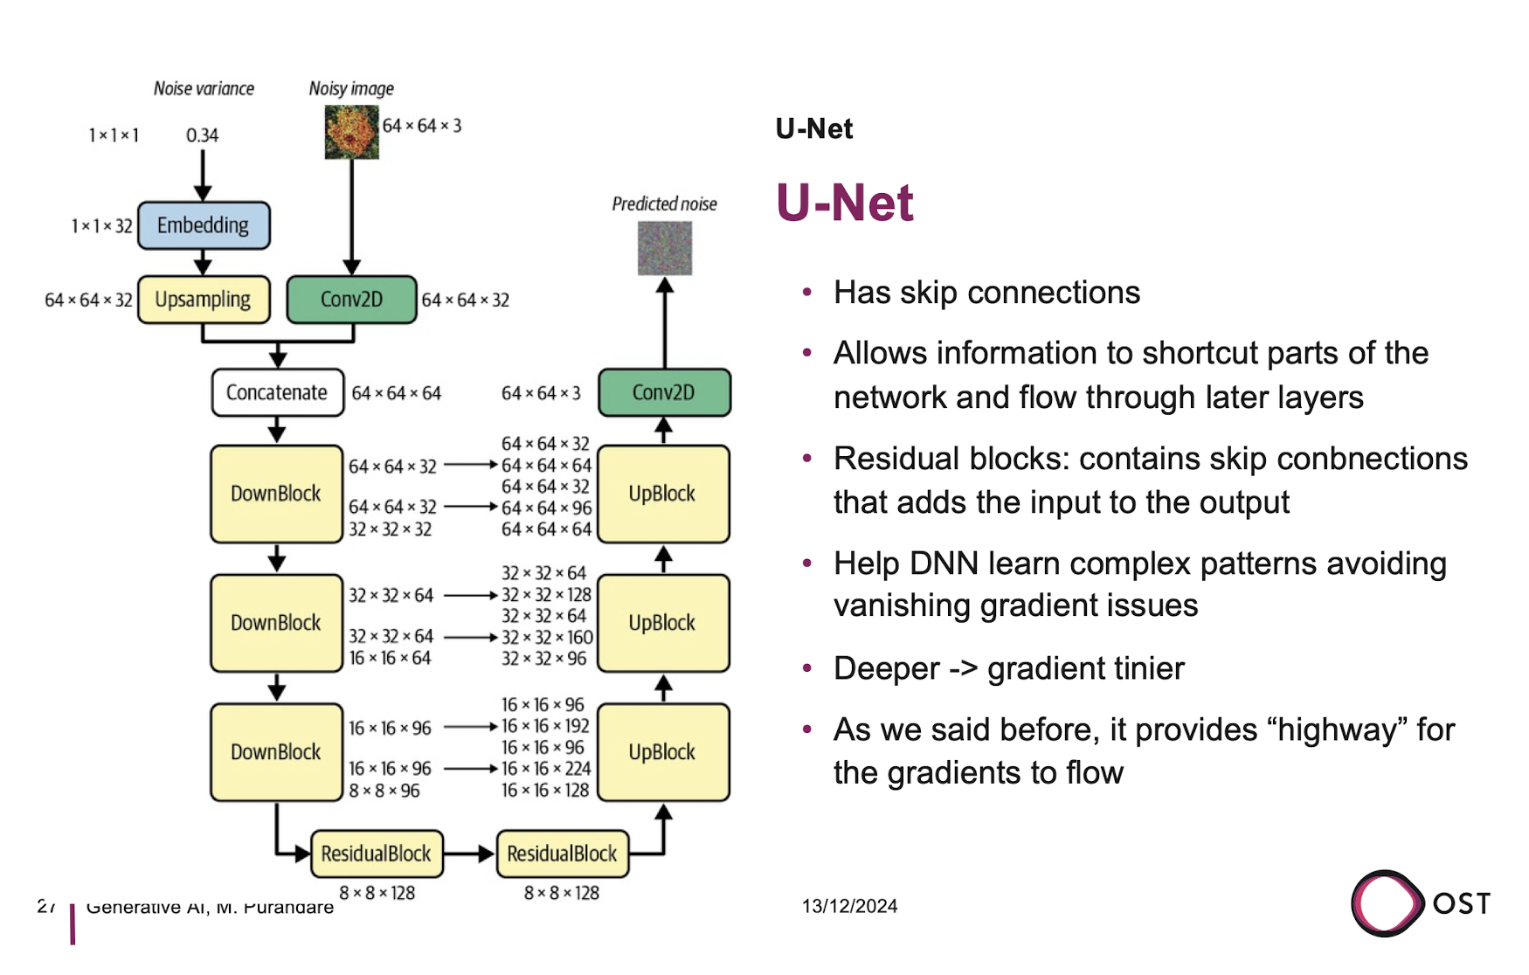
Why do we input Noise Variance into the UNET? It needs to know that and we know what variance we have used to corrupt (i.e. noise) the image

Does the Neural network need to be retrained for every image size? No. Only if difference is large. U-Nets, particularly in Stable Diffusion, are designed to handle images of variable sizes due to their fully convolutional architecture. As long as the image dimensions are divisible by the strides of the downsampling operations, the network can process images of various sizes without requiring retraining. Otherwise, padding is added.

