Moodle:
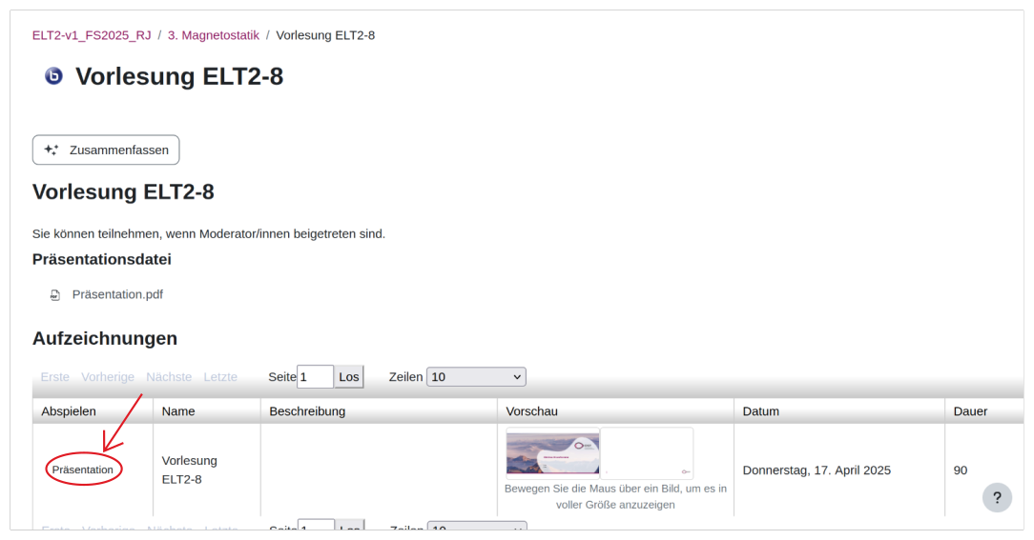

COPY Link

Go to
https://kuna.fish/bbbexp.html


